Case 5-A350-Asia-Thailand-Ban Chiang-Ceramics-Red-on-buff-4600 BCE

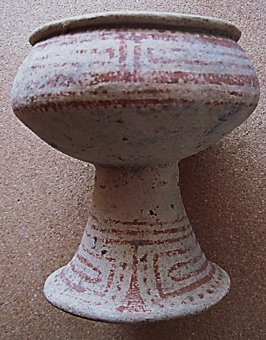 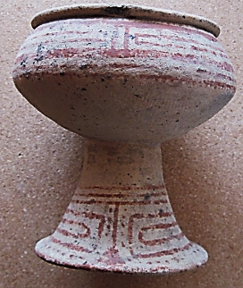

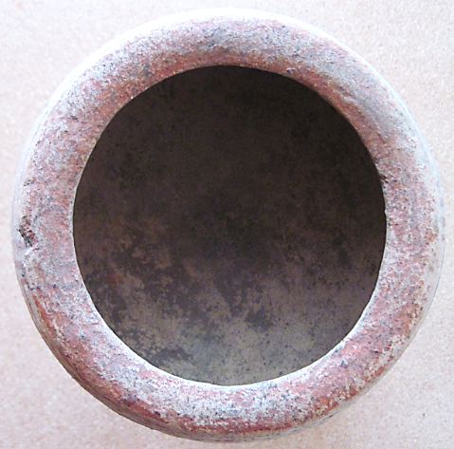

Figs. 1-3. Thailand-Ban Chiang-Ceramics-Red-on-buff-4600 BCE

**Case No.: 5**

**Accession Number: A350**

**Formal Label:** Thailand-Ban Chiang-Ceramics-Red-on-buff-4600 BCE

**Display Description:**

“The red-on-buff painted pottery of northeastern Thailand provides an opportunity to reevaluate assumptions of cultural development in Southeast Asia. This striking pottery is characteristic of the early bronze-using cultures of Northeast Thailand, and is represented at the sites of Non Nok Tha, Ban Chiang, and Non Ban Kho (Bayard 1971: 36), as well as at other sites in the area that have not yet been reported. The excavated sample in the hands of professional archaeologists is not large, nor has much detailed analysis of this pottery been published.

Although the red-on-buff ware is not the only ware at Non Nok Tha, it is

associated with the layers containing the early bronze, stratigraphic layers 20 and 21

(according to Bayard's excavation, cultural level 3). Several vessels and assorted

sherds are similar to the ware from Ban Chiang, a cemetery site northeast of Non

Nok Tha. This site, first excavated by Vidya Intakosai in 1967, and then by other

archaeologists from the Thai Fine Arts Department whose work is still in progress,

is the richest source of this painted ware. The Applied Science Center for Archaeology

at the University of Pennsylvania Museum recently ran a series of thermoluminescence

tests on sherds from Ban Chiang; the following results were reported

(Bronson and Han 1972: 323): sample 104 4630 B.C. ± 520; sample 271 3570 B.C. ± 480; sample 273 3590 B.C. ± 275” (van Esterik 1974).

**LC Classification:** DS589.B17

**Date or Time Horizon**: 300 BCE-300 CE

**Geographical Area:** Ban Chiang, Udon Thani, Thailand

**Map:**

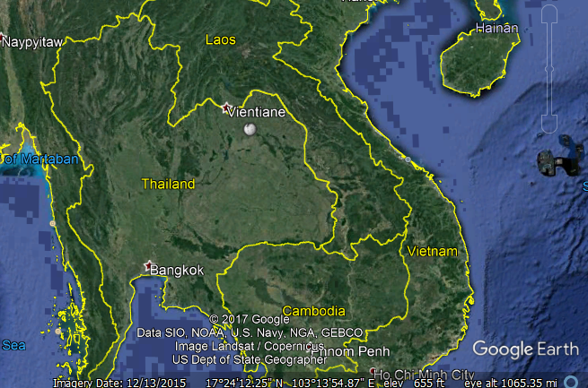

Fig. 4. Ban Chiang is near Vientiane

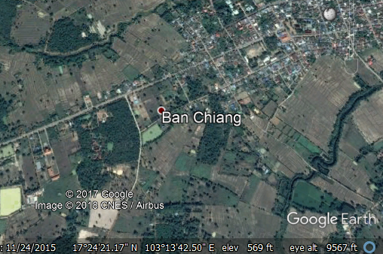

Fig. 6. Detail of Ban Chiang location

**GPS coordinates:** [17°24′25″N 103°14′29″E](https://tools.wmflabs.org/geohack/geohack.php?pagename=Ban_Chiang&params=17.4069_N_103.2414_E_type:landmark_region:TH-41)

**Cultural Affiliation:** Ban Chiang

**Medium:** ceramic, red on buff

**Dimensions**: Dia. of lip, 131.43 mm, 5.175 in; H 145.87, 5.743 in  
**Weight: 656 g, 1 lb 7 1/8 oz**

**Provenance: Ban Chiang**

**Condition: original**

**Discussion: (UNESCO) http://whc.unesco.org/en/list/575**

The Ban Chiang Archaeological Site is a large, prehistoric earthen mound located in an agricultural area in the Ban Chiang Sub-district, Nong Han District of Udon Thani Province in northeast Thailand, within the watershed of the Mekong River. It is an oval-shaped mound formed by human habitation 500 meters x 1,350 meters and 8 meters high. The site was first discovered in 1966. It has since been extensively excavated and its remains studied by Thai and international scholars. Since 1966 the dating of the site has been adjusted and refined over time in line with advances in the understanding and techniques of radiometric dating. This research has revealed that the site dates from 1,495 BC .and contains early evidence for settled agrarian occupation in Southeast Asia, along with evidence of wet rice agriculture, associated technological complex of domesticated farm animals, ceramic manufacture, and bronze tool-making technology. The total area of the property is 67.36 ha of which approximately 0.09% has been excavated (as of 2012)

The Ban Chiang Archaeological Site is a prehistoric human habitation and burial site. It is considered by scholars to be the most important prehistoric settlement so far discovered in Southeast Asia, marking the beginning and showing the development of the wet-rice culture typical of the region. The site has been dated by scientific chronometric means (C-14 and thermo luminescence) which have established that the site was continuously occupied from 1495BC until c. 900BC., making it the earliest scientifically-dated prehistoric farming and habitation site in Southeast Asia known at the time of inscription onto the World Heritage List.

The Ban Chiang cultural complex is well-defined and distinctive from anything that preceded it. Through it can trace the spread and development of prehistoric society and its development into the settled agricultural civilizations which came to characterize the region throughout history which still continue up to the present day. Advances in the fields of agriculture, animal domestication, ceramic and metal technology are all evident in the archaeological record of the site. Also evident is an increasing economic prosperity and social complexity of the successive communities at Ban Chiang, made possible by their developing cultural practices, as revealed through the many burials, rich in ceramic and metal grave goods, uncovered at the site.

The Ban Chiang Archaeological Site is also the richest in Southeast Asia in the number and variety of artifacts recovered from the site. As such, the property has been extensively studied by scholars as the archaeological “type-site” for the beginnings of settled agricultural communities and their associated technologies in the region.

Ban Chiang Archaeological Site was the centre of a remarkable phenomenon of human cultural, social, and technological evolution which occurred independently in this area of Southeast Asia and began at Ban Chiang around 1500 B.C. and spread widely over the whole region.

References:

Higham, Charles. 1998. *Prehistoric Thailand*. River Books; 1st Edition edition.

Higham C.F.W. and T.F.G. Higham 2009. “A new chronological framework for prehistoric Southeast Asia, based on a Bayesian model from Ban Non Wat,” *Antiquity* 82:1-20.

Higham C.F.W. 2011. The Bronze Age of Southeast Asia: new insight on social change from Ban Non Wat. *Cambridge Archaeological Journal* 21(3): 365-89

Higham C.F.W., R. Ciarla, T.F.G. Higham, A. Kijngam and F. Rispoli. 2011. “The establishment of the Bronze Age in Southeast Asia,” *Journal of World Prehistory* 24 (4),227-274:

Higham C.F.W., T.F.G. Higham and A. Kijngam. 2011. “Cutting a Gordian Knot: The Bronze Age of Southeast Asia, timing, origins and impact,” *Antiquity* 85:583-98.

Labbe, Armand. 1985. *Ban Chiang: art and prehistory of Northeast Thailand*. Santa Ana, CA: Bowers Museum.

Labbe, Armand. 2002. *Prehistoric Thai ceramics : Ban Chiang, Lopburi, and Khok Phanom Di and related sites in regional cultural perspective*. Bangkok, Thailand: White Lotus.

Pietrusewsky, Michael and Michele Toomay Douglas. 2002. [*Ban Chiang, a prehistoric village site in northeast Thailand / 1, The human skeletal remains.*](http://www.worldcat.org/title/ban-chiang-a-prehistoric-village-site-in-northeast-thailand-1-the-human-skeletal-remains/oclc/773050324&referer=brief_results) Philadelphia, PA : The University of Pennsylvania, Museum of Archaeology and Anthropology.

### van Esterik, Penelope. 1974. “A Preliminary Analysis of Ban Chiang Painted Pottery, Northeast Thailand,” *Asian Perspectives*, XVI(2): 174-194.

White, J.C. and Hamilton, E. G. 2009. “The Transmission of Early Bronze Technology to Thailand: New Perspectives,” *World Prehistory* 22: 357–397.

White, J.C. 2008 “Dating Early Bronze at Ban Chiang, Thailand.” In *From Homo erectus to the Living Traditions*. Pautreau, J.-P.; Coupey, A.-S.; Zeitoun, V.; Rambault, E., editors. European Association of Southeast Asian Archaeologists, Chiang Mai, pp. 91-104.

White, J. C. 1995. “Incorporating Heterarchy into Theory on Socio‐political Development: The Case from Southeast Asia,” *Archeological Papers of the American Anthropological Association*, 6(1), 101-123.

White, J.C. 1986. A Revision of the Chronology of Ban Chiang and Its Implications for the Prehistory of Northeast Thailand. Unpublished Ph.D. dissertation, Department of Anthropology, University of Pennsylvania, Philadelphia.